

Contamination Level Detection Based on Applied Volatege and Leakage Current

Using Machine Learning Techniques



# Abhinaba Chakraborty, 4th Year

# B1 - 001610801146

# Under

# Dr. Sovan Dalai

# Department of Electrical Engineering, Jadavpur University

Abstract—In order to assess how severe, the contamination level of the surface of power line insulators and to prevent unpredictable contamination flashovers, it is important to seek optimal prediction characteristics. That leads to the increase of the warning time and to the improvement of the reliability of the pre-warning system. The three characteristics of the leakage current, namely the mean value, maximum value, and the standard deviation of the root-mean-square (RMS) value of the leakage current, have been extracted. There are other features that were extracted too. They describe the current contamination levels of an insulator surface. In addition, regression equations between the three characteristics and various contamination levels have been established. The same three characteristics have been selected and used as the inputs of a machine learning model. Also, the influence of each characteristic on the contamination prediction results has been investigated. The model is appropriate to predict the equivalent salt deposit densities (ESDD). This research results in the optimal prediction input parameters and sufficient pre-warning time before a contamination flashover.

# Introduction

Insulators used in outdoor electric power transmission lines are exposed to outdoor environmental contaminations. Contamination on outdoor insulators enhances the chances of flashover. Depending on the nature and duration of exposure, deposits of wind-carried industrial, sea and dust contaminants build up on the insulator surface as a dry layer. The leakage current path through a layer of dry contaminants on an insulator surface is capacitive wherein the current amplitude is small and sinusoidal. The dry contaminant layer becomes conductive when exposed to current amplitudes. The increase in leakage current dries the conducting layer and forms the dry bands around the areas with high current density. These dry bands interrupt the current flow and most of the applied voltages are impressed across these narrow dry bands. If the dry bands cannot withstand the voltage, localized arcing develops and the dry bands will be spanned by discharges. The arcs merge together and form a single arc, which triggers the surface flashover (Jeyakumar, 1991).

The contamination severity determines the frequency and intensity of arcing and, thus the probability of flashover. In favorable conditions when the level of contamination is low, layer resistance is high and arcing continues until the sun or wind dries the layer and stops the arcing. Continuous arcing is so light rain or morning dews. As wetting progresses, the leakage current path changes from capacitive to resistive with simultaneous increase in harmless for ceramic insulators. The mechanism described above shows that heavy contamination and wetting may cause insulator flashover and service interruptions. Contamination in dry conditions is harmless. Hampton investigated the voltage distribution along the wet, polluted surface of a flat insulating strip and the method of dry band formation, with subsequent growth of discharges on the polluted surface (Hampton, 1964). Karady measured the peak leakage current and correlated the current with the flashover voltage. He suggested that the flashover is imminent if the leakage current peak exceeds 100 mA (Karady et al., 1999). In practice, there are various contaminant types that settle on outdoor insulators. These contaminants can be classified as soluble and insoluble. Insulators located near coastal regions are typically contaminated by soluble contaminants, especially salt (or sodium chloride). Insulators located near cement or study industries are typically contaminated by non-soluble contaminants such as calcium chloride, carbon and cement dust. Irrespective of the type of contaminant, flashover can occur as long as the salts in the contaminant are soluble enough to form a conducting layer on the insulator’s surface. In order to quantify the contaminants on the surface of the insulators, the soluble contaminants are expressed in terms of Equivalent Salt Deposit Density (ESDD), which correlates to mg of NaCl per unit surface area. Non soluble contaminants are expressed in terms of Non-Soluble Deposit Density (NSDD), which correlates to mg of kaolin per unit surface area. Many researchers studied that the leakage current due to the contamination level is the main cause for flashover. Farag, (1995) applied ANN as function estimators in the insulator flashover studies. The training and the test data of ANN are obtained from the experimental studies carried out on a flat plate model of polluted insulator under power-frequency voltage. The combinations of ANN parameters which give best result are clearly identified and the model results are compared with the experimental results. In Guan Zhicheng and Guoshun (1994) the maximum value of leakage current has the definite relationship with the flashover voltage of the polluted insulator used to express the pollution degree of insulator. Artificial neural networks can be used in problems requiring function approximation, modeling, pattern recognition and classification, estimation and prediction (Haykins, 1998, Limsombunchai and Minso, 2004; Moussaoui et al., 2006). Li et al. (2010) extracted three characteristics of the leakage current, namely the mean value, maximum value and the standard deviation of the Root- Mean Square (RMS) value of the leakage current, from the recorded value. They describe jointly the current contamination levels of an insulator surface. In addition, regression equations between the three characteristics and various contamination levels have been established. The same three characteristics have been selected and used as the inputs of neural network model.

# Analysis of Given Data

We have a excel file named “Porcelain Data 1.3.19” where there are 5 sheets. Each sheet corresponds to five different kind of Contamination Level. For each Contamination Level we have leakage current samples for each Voltage Levels. Voltage Levels are 5kV, 10kV, 15kV, 20kV, 25kV, 30kV.

The Leakage current values are the sampling current flowing through the contaminated surface of the insulators. For the given data set we can have a leakage current sinusoidal graph something like the below diagram,

1: Leakage Current for 15kV applied Voltage and Very Low Contamination Rate

After a comprehensive evaluation, it was quite obvious that some values are repeated for multiple cases (As it all the leakage current is sample of corresponding sinusoidal graph so overlapping is a common issue.).

2. Leakage Current Comparison between 10kV and 20kV Voltage Level and Medium Contamination Level

So simple classification or regression techniques will not help. We need to extract some features.

Root mean square values for each voltage level and each contamination level have been calculated.

$$Root mean square=\sqrt{\frac{Σ{(samples of leakage current of each voltage level at corresponding Contamination level)}^{2}}{Total Number of Samples}}$$

After that for each voltage level data for five mean square value of leakage current and corresponding contamination level have been prepared. From that data regression model has been prepared for each voltage level. From that an idea about the relationship between mean square value and contamination rate can be derived.

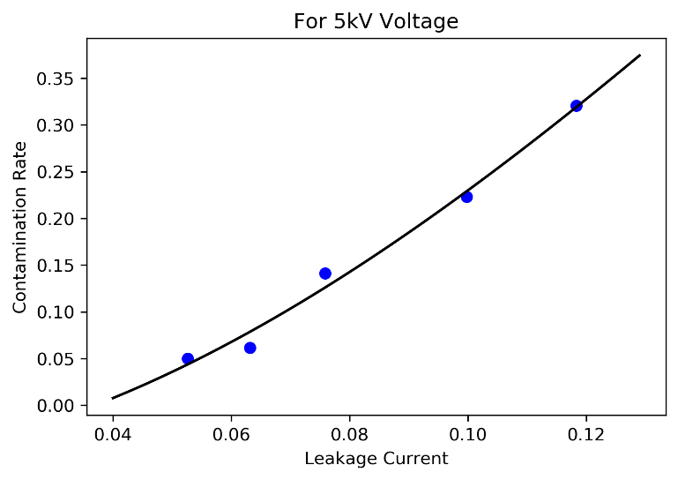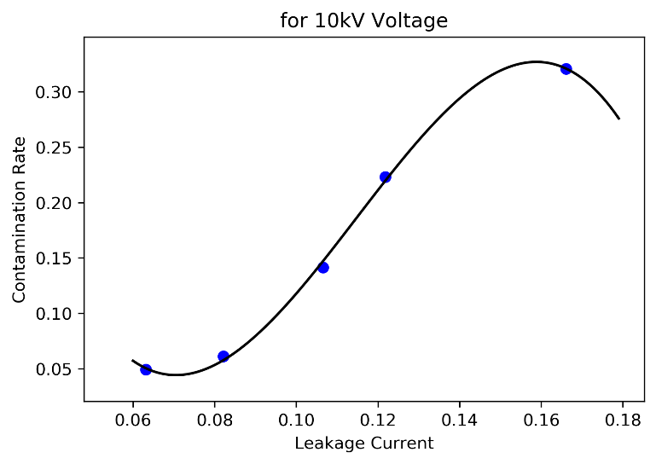

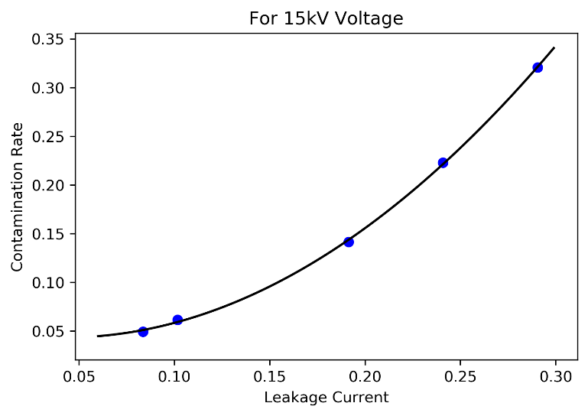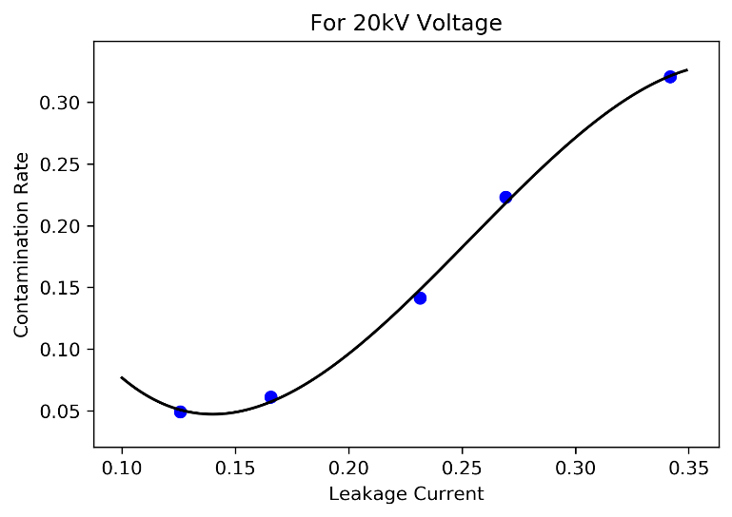

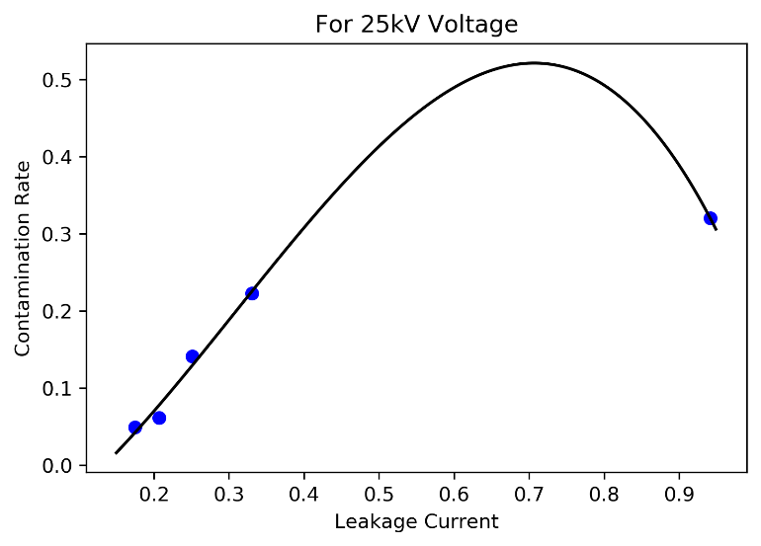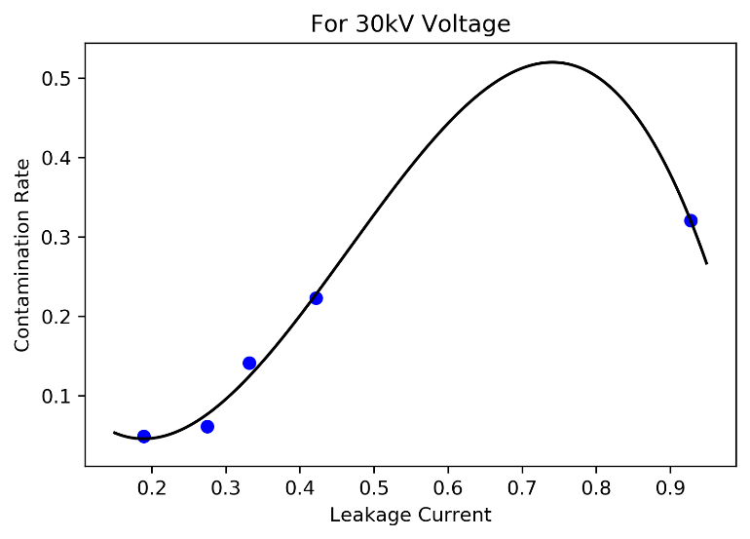

As it can be seen from the previous graphs it is evident that contamination rate is proportional to cube of leakage current. It is actually proportional to sixth power of leakage current but as far as our problem is concerned taking the later relationship will overfit the curve that is not a good sign for a regression model.

# Machine Learning Model for Predicting Contamination Level

It is desired to estimate how severe the contamination is on the insulator surface. The emphasis of this problem is to find the appropriate information based on the leakage current. The evaluation results can provide a guide for the operators about possible cleaning of insulators. That is basically the ultimate aim of the detection of the leakage current. The prediction model should meet the engineering reliability and convenience, especially for the machine learning model construction and data processing. Based on the results above, four main characteristics (Standard Deviation, Max Value, Skewness, Kurtosis) have been extracted. These four features can be used as inputs for the prediction model in combination with the applied voltage and relative humidity.

## Feature Extraction

Different Kinds of Supervised Classification Techniques (Because we have categorical value) can be used in many problems requiring function approximation, modeling, estimation and prediction.

We have a data for 10kV voltage. In each sheet we have five columns of sample leakage current that resembles the harmonic for a particular contamination level (each sheet corresponds to a particular contamination level). For each column we determine Standard Deviation, Max Value, Skewness, Kurtosis. At last we have total of 25 rows of data for a particular voltage. (i.e. 10kV)

$$Val_{Max}=max⁡(all the samples for each coloumn for each contamination level)$$

$$Skewness=\frac{{Σ(x_{i}-μ)}^{3}}{(n-1)σ^{3}}$$

$$Kurt\left[X\right]=E[({\frac{X-μ}{σ})}^{4}]$$

In order to predict the contamination level K-Nearest Neighbor has been selected because same type of values of making kind of cluster in particular area, so KNN will give the best result.

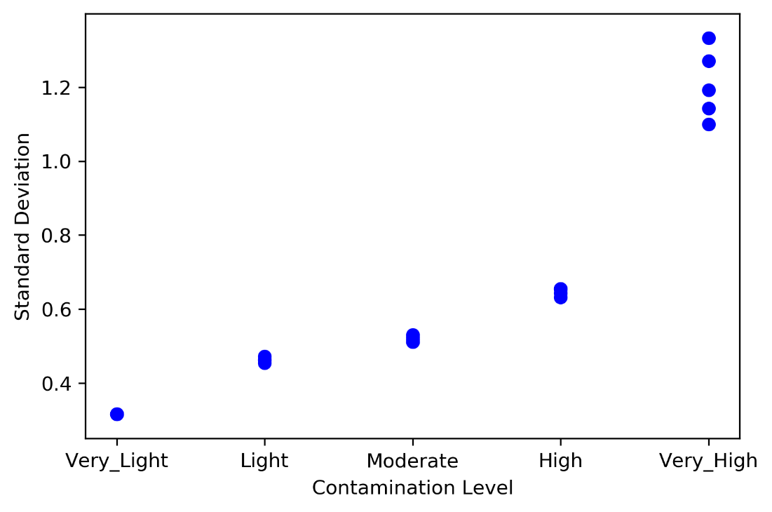

3. Standard Deviation for different Contaminations Level

## Train-Test Split and Building Model

As we work with datasets, a machine learning algorithm works in two stages. We usually split the data about 20%-80% between testing and training stages. Under supervised learning, we split the data into a training dataset and test dataset randomly. Random split will actually result in better splitting. After that the training set will feed to the algorithm and based on the training set and manually set value of K (in our case K=3) algorithm will produce a model that will predict the test set.

## Accuracy testing

Using the model, we predicted the output of test dataset and compare them with existing contamination rate of test dataset. We actually got **92%** accuracy (highest for any classification Algorithm).

The classification report is as follows,

|  |  |  |  |
| --- | --- | --- | --- |
| f1-score | precision | recall | support |
| 1 | 1 | 1 | 3 |
| 0.667 | 0.5 | 1 | 1 |
| 0.8 | 1 | 0.667 | 3 |
| 1 | 1 | 1 | 2 |
| 1 | 1 | 1 | 3 |
| 0.917 | 0.917 | 0.917 | 0.917 |
| 0.893 | 0.9 | 0.933 | 12 |
| 0.922 | 0.958 | 0.917 | 12 |

# Conclusions

1. In this study, a new kind of method has been proposed to predict how severe the contamination level of insulators is, it is based on the contamination of the insulators is. It is based on the characteristics of the insulator leakage current.
2. The four main feature of the leakage current Standard Deviation, Max Value, Skewness, Kurtosis can predict the general contamination level of insulator surfaces during the security stage.
3. We actually done the classification based on a single voltage level. Different voltage levels can be included for better prediction.

It should be noted that the saturated humid condition is an effective test condition for the leakage current in the laboratory. The main purpose of this project is to look for a new and convenient way for contamination flashover pre-warning based on the leakage current values. In fact, the contamination flashover often occurs during winter when the relative humidity is lower, but the contamination is heavy, cleaning (washing) the insulators is very difficult, and the leakage currents are also small. Once there is more rain, the leakage current would increase rapidly after the contamination layer becomes moist. Contamination flashovers may likely appear then in a very short time.

The main goal of the research has been to ensure that the prediction of a contamination flashover would be available at the security stage. There is still a lot of work to do for the real practical application.

# Acknowledgement

This project on Contamination Level Determination based on Applied Voltage and Leakage Current completed as a project work for our 4th Year 1st semester. It involves the Determination of Contamination of Insulating materials using Machine Learning Techniques and find the relation between contamination rate and leakage current. I started out native confident on our theoretical knowledge and soon realized that there is more to work what’s stated in the books. I got to learn about insulators and contamination levels and through it, I had a small glimpse into the complexities of High Voltage Systems. What had started out as a routine sessional work turned out to be greatly challenging and engrossing job that taxed our spirit to the fullest.

Appreciative acknowledgements are extended to my project supervisor, **Dr. Sovan Dalai**, Associate Professor, Electrical Engineering Department, Jadavpur University, Kolkata. He has given continuous support and encouragement throughout the project. I would like to express gratitude towards Jadavpur University for providing me this great opportunity. My thanks and appreciations also go to the other professors of Jadavpur University, who willingly encouraged me to explore different fields of Electrical Engineering.

# References

|  |  |
| --- | --- |
| [1] | M. A. K. A. A. S. A. H. M. Iman Ahmadi Joneidi, "Leakage current analysis, FFT calculation and electric field distribution under water droplet on polluted silicon rubber insulato," December,2013. |
| [2] | S. C. C. Muniraj, "Analysis of leakage current on polluted polymer insulator by high resolution spectrum estimation method," *2009 International Conference on Power Systems,* 2009. |
| [3] | B. X. Du, Y. Liu, H. J. Liu and Y. J. Yang, "Recurrent plot analysis of leakage current for monitoring outdoor insulator performance," *IEEE Transactions on Dielectrics and Electrical Insulation ,* vol. 16, pp. 139 - 146, 20 February 2009 . |